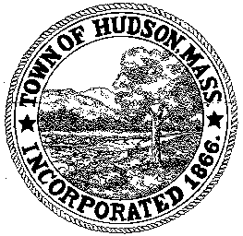

CONSERVATION COMMISSION
78 Main Street, Hudson, MA 01749
(978) 562-2020

Paul Byrne, Chairman W. Minot Wood, Vice Chairman David Esteves, Member

Terrence Joyce, Member Leif Longtine, Member Joseph Rodrigues, Member Al Tashian, Member

Meeting Agenda
July 14, 2011 7:00 P.M.

- Preliminaries
  - Open Meeting
  - Roll Call

2.0 New Business
2.1 RDA 408
Location: 91 Park Street
Applicant: Dennis Zilembo/BPOE
Project Description: Build a 52’x10’ bocce court

2.2 Nicolas and Candis Clare
Location: 478 Main Street - violation

2.3 Alec Crawford Location: 12 Old Bolton Road

2.4 James Patry – Eagle Scout Project

2.5 Voucher
ConCom 063011 $934.07
ConCom 071411 $394.00

2.6 Minutes – June 30, 2011

3.0 Old Business

4.0 Correspondence
4.1 Lake Boon Treatment Plan
4.2 Request for Review and Comment – Bush Road

5.0 Adjournment:

Next Meeting: August 18, 2011

